ANKARA UNIVERSITY
ENGINEERING FACULTY
DEPARTMENT OF COMPUTER ENGINEERING

INTERNSHIP REPORT

SET UP A JOB WEBSITE

Abdullah Gür
14290100

August 2018
ABSTRACT
Looking for a job is a problem which almost everyone is at the top of their agenda in a period. Looking for a job and not finding a place in a suitable position often pushes people to despair. The websites also changed the way of the looking for a job such as they changed everything. http://bilirisi.com/ also make an effort for being a platform like most job websites can be used easily for job seekers and employers. This site will be a job site and a career site that will enable everyone to find their dream job especially university graduates. The site that started to be set up by company in line with this purpose and then its construction was abandoned. Therefore, I tried to keep the construction of the site up as much as I could.
INSTITUTION INFORMATION
Institutions;
Name : Devr-i Robotik Arge

Department : Devri Robotik Arge Mekatronik Elektronik Yazılım Mühendislik Danışmanlık Bilişim Otomasyon Savunma İthalat İhracat San. Ve Tic. Ltd. Şti.

Address : Bahçelievler Mah. 320. Sok. Gazi Teknoloji Geliştirme Bölgesi 3-B Gazi Teknopark - Teknoplaza Binası A-214 06830 Gölbaşı - ANKARA / TURKEY

Telephone : 03122664664

Cellphone : 05324621194

E-mail : cemilbakikiyak@gmail.com

Web Page : http://www.devrirobotik.com/

TABLE OF CONTENTS
ABSTRACT i
INSTITUON INFORMATION ii
TABLE OF CONTENTS iii
INTRODUCTION 1
1. RELATED TO LOG-IN & SIGN-UP PAGE 2
1.1. Password Authentication Error 2
1.2. Password Constraints 6
1.3. reCAPTCHA Application 8
2. RELATED TO SESSION & COOKIE 10
2.1. What is the Session? 10
2.2. Refresh the Current Page 11
2.3. How to use the Cookies? 12
3. RELATED TO PERSONAL INFORMATION PAGE 13
3.1. Save the Personal Information in the Databases 13
3.2. Show the Province & District Databases in the Personal Information Page 15
4. LOG-IN & SIGN-UP WITH GOOGLE & FACEBOOK 18
4.1. Why is the Sign-up through Social Network Important for Any Users? 18
4.2. How to Log-in & Sign-up with Google? 18
4.3. How to Log-in & Sign-up with Facebook? 19
4.4. Social Media Accounts 19
5. SHOW THE CV PHOTO 20
5.1. Save the Cv Photo in the Database 20
5.2. Show the Cv Photo in the User Profile 20
5.3. Show the Saving Picture in the User Profile 21
APPENDICES 22
Appendix-1. Password Constraints 22
Appendix-2. Cookies Codes in the Localhost 24
Appendix-3. ajaxililce.php and Personal Information Page 26
Appendix-4. Log-in & Sign-up with Google Codes in the Localhost 28
Appendix-5. Log-in & Sign-up with Facebook Codes in the Localhost 30
Appendix-6. Cv Photos 33
CONCLUSION 34
BIBLIOGRAPHY 35

INTRODUCTION
The task given to us during the internship is fix the mistakes and to complete the deficiencies of the http://bilirisi.com/ site (a job site like Kariyer). In my report, the php codes of http://bilirisi.com/ site by understanding, I have included mistakes I could fix and the deficiencies I could add. (While we started doing this, we received a little bit information about the site from the internship place. I completely tried to fix the mistakes and the deficiencies as a result of my research on the internet on my own.) Of course, in order to do this, I tried to test my own additions with small trial phps via Localhost. I fixed the some problems of the site and I couldn't fix the some problems despite of my striving. I will try to mention these problems in the report, respectively.
- RELATED TO LOG-IN & SIGN-UP PAGES
  - Password Authentication Error
While I tried to log-in to the Employee or Company section, I added an extra digit by accident when I entered my password. However, I was surprised when the session was opened and I noticed this problem. Problem; For example, if the password is more than 8 digits like “Bilirisi123”, it compares only the first 8 digits of this password with the encrypt form in the database. In other words, even if the user entered different things to the password box like “Bilirisi” or “Bilirisi456”, the session was opened without any problem. If the only first 8 digits are correct, that is enough. I searched on the internet to fix this problem. What do the websites use when verifying user passwords?
Nowadays, symmetric and asymmetric encryption algorithms are used. A private key is used for encryption and decryption in the Symmetric Encryption Algorithms. The key that used is hidden from the others and a common key that is understood between the person that encrypt and those who will decode the encryption. The private key that is agreed with the private text to be sent together is sent to the recipient and the decryption process is performed. The most big problem is the key distribution in the Symmetric Encryption Algorithms. In a multiuser system using symmetric algorithms, deploying the same key to all users can be problematic for security. If you give a different key to each user, there may be a lot of diffirent keys in the system. To solve these problems, Asymmetric Encryption Algorithms have been developed. In this algorithm, the key and the decryption key are different. The key is the public key, and the key that decrypts the private key (ITUBIDB, 2013).¹

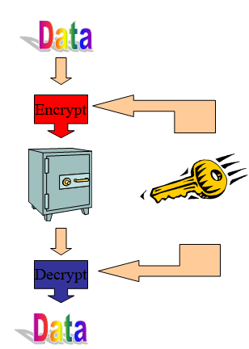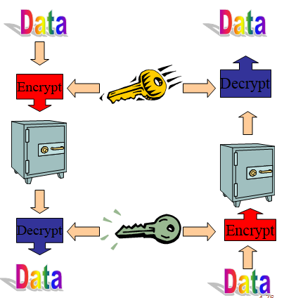
Figure 1.1.1. Symmetric Encryption² Figure 1.1.2. Asymmetric Encryption²
I have been informed about various encryption algorithms such as crypt(), md5(), blowfish(), hash(), which are symmetric and asymmetric encryption. MD5 is a 128-bit hash function used in encryption systems. MD5 simply converts any size of message to a 128-bit length. In addition, MD5 is a one-way algorithm, so there is no recycling. The password cannot be decrypted because the password is stored as the MD5 algorithm in the user name and the password applications, and if the user forgets the password, the system cannot give the old password and the user is assigned a new password (bilgisayarkavramlari, 2008).³ Therefore, I applied the MD5 algorithm to the incorrect part in mainpc.php.
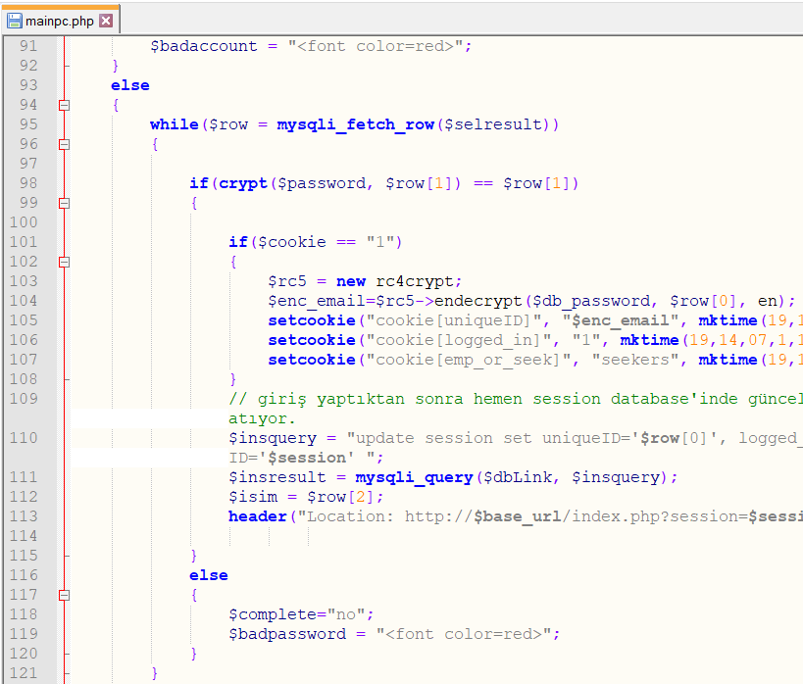 Figure 1.1.3. Code snippet in the old mainpc.php
I have done compare with the hash function to the entered password in the line 98th of mainpc.php with the encrypted password in the database (Figure 1.1.4).
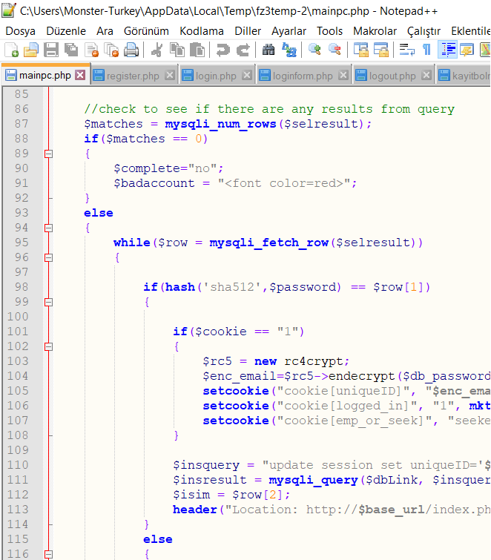 Figure 1.1.4. Code snippet in the update mainpc.php
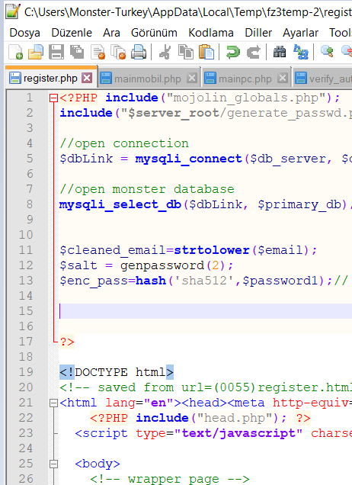 Figure 1.1.5. Save the database as hash
I have fixed line 13th in register.php for save the password to the database as 128-bit hash. Figure 1.1.6 shows how a password is stored in the database.
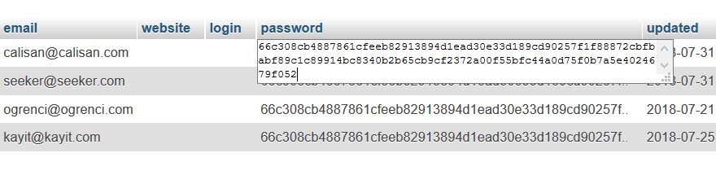Figure 1.1.6. The 128-bit hash version of “Abdullah12345” password in the jobseeker.sql

  - Password Constraints
As are most websites, I needed to add some constraints to encryption to secure our users and protect their sessions against external attacks. What constraints can we add to user passwords?
A password policy is a set of rules designed to enhance computer security by encouraging users to employ strong passwords and use them properly. A password policy is often part of an organization's official regulations. Either the password policy is merely advisory, or the computer systems force users to comply with it (Wikipedia).⁴ The rules which constrain the form of a password. Some passwords are quite easy for an intruder to guess. For example, short passwords containing only alphabetic characters can be cracked very easily. Password constraint is the process of rejecting passwords based on criteria specified by a system administrator or a security administrator. Users may be prevented from creating short passwords, passwords which have the user's name contained in it, or passwords which do not include at least one non-alphabetic or numeric character. The rejection of a password is normally carried out by an operating system or software tool when a user attempts to create a new password or change an existing password (Oxford Reference).⁵
Constraints on user passwords on the site; -The password must be at least 6 and maximum 16 characters. -The password must contain at least one uppercase letter, at least one lowercase letter, and at least one digit. -The password must only contain
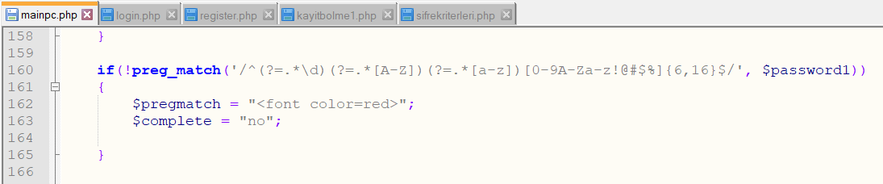 Figure 1.2.1. Password Criterias
some special characters. When the password did not comply with these criteria, I gave a warning by line 84th in the kayitbolme1.php. (I will share the sifrekriterleri.php in the Appendices.)
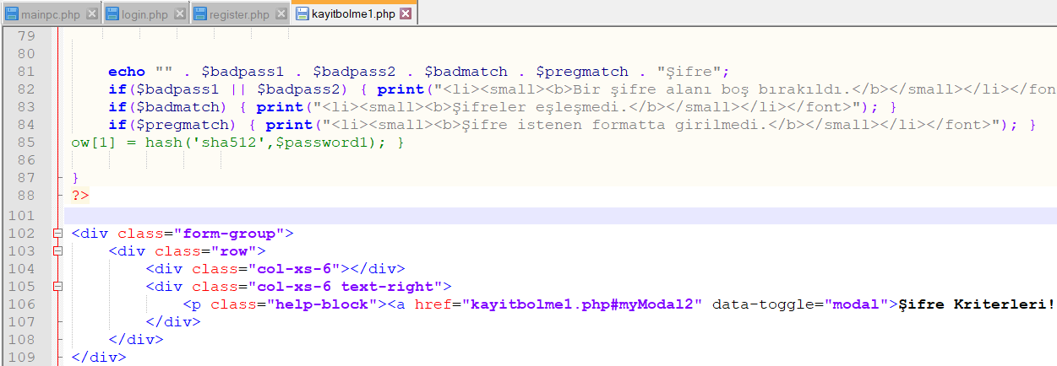 Figure 1.2.2. Check the password and show the password criterias in Sign-up page
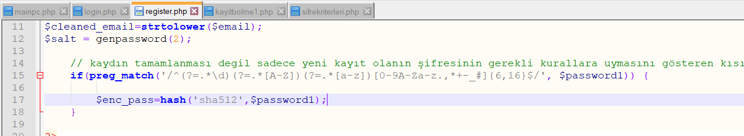 Figure 1.2.3. Save the password in the database if it is a proper password
With the constraints imposed on the password, we have forced users to create a separate and more complex password than the conceivable all passwords have been created in the database which they call dictionary database by spies. Otherwise, a spyware who accesses the database of the site would have made it eaiser to check if the hash passwords that were created from numbers or letters could be compared with all the data in their databases.

  - reCAPTCHA Application
On the sign-up page, one of the deficiency I noticed it was not “I’m not a robot!” extension that being on most sites. Why should users perform such an extension when creating a new register? What is reCAPTCHA that the one of the Google’s applications?
reCAPTCHA is a CAPTCHA-like system designed to establish that a computer user is human (normally in order to protect websites from bots) and, at the same time, assist in the digitization of books (Wikipedia).⁶
I made it appear on the sign-up page by adding this to mainpc.php. I took the 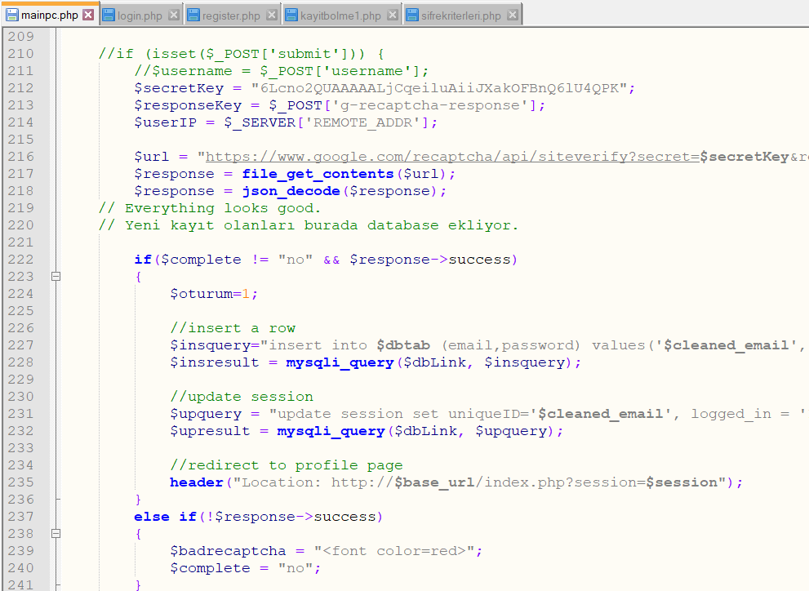 Figure 1.3.1. Code snippet of reCAPTCHA app in mainpc.php
necessary $secretKey, $responseKey, $url values from Google. $complete, if it was not “no”, the new user was registered directly. Thereby I add $response->success, I have made it not save the ones who want to register without using the “I’m not a robot!” app, and I also have returned the error message to the screen if it is not used.
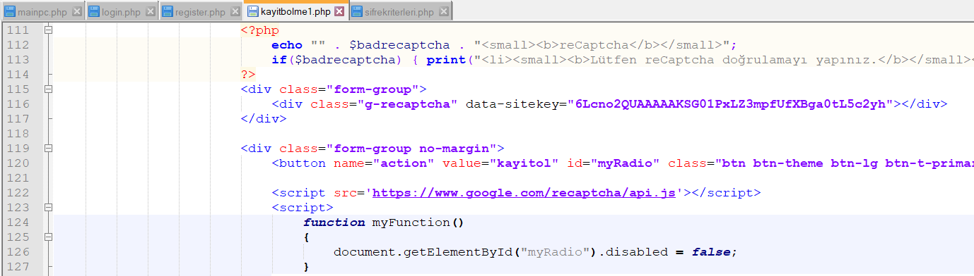 Figure 1.3.2. Show the reCAPTCHA app in the sign-up page

- RELATED TO SESSION & COOKIE
  - What is the Session?
When you want to trade with any software on your computer, the software is opening, changes are made on the software, and close as a result. During all these processes, the computer knows who you are, when you started the software and you ended it. But when you do the same on a server, the server doesn’t have any idea who you are or detection what you do when. Here at this stage, it has been brought the session concept as a solution the collecting of the necessary information to the system. Sessions store information about you in the server, so that the same software example on your computer is working on a web software (Wm Araci).⁷
Users are assigned a random SessionID in session.php in order to register to changes that make in their session, and when they log-in their session. This 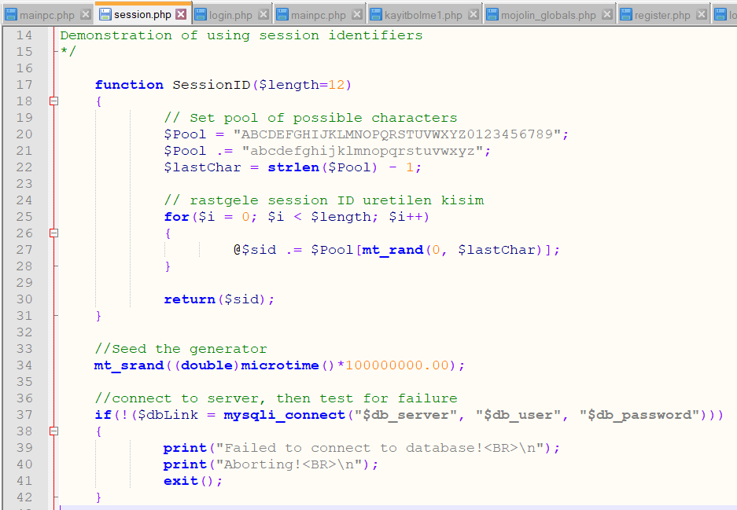 Figure 2.1.1. Create a SessionID for any user into the microseconds
SessionID of the users are saved in the session database until they log-out.
  - Refresh the Current Page
On most sites like Facebook and Twitter, our LastAction is even a long time away, but our session doesn’t log-out. However, if a user’s LastAction on the http://bilirisi.com/ is 30 minutes before another user’s logging-in time, or leave session without logging-out the page, that user is deleted with delete command in the session database. When the first of these situations is happened, we change LastAction by automatically refreshing page with the refresh command at the minute 29th before the 30 minutes expire. So, LastAction is equal to “now - 60” happening in that user’s SessionID.
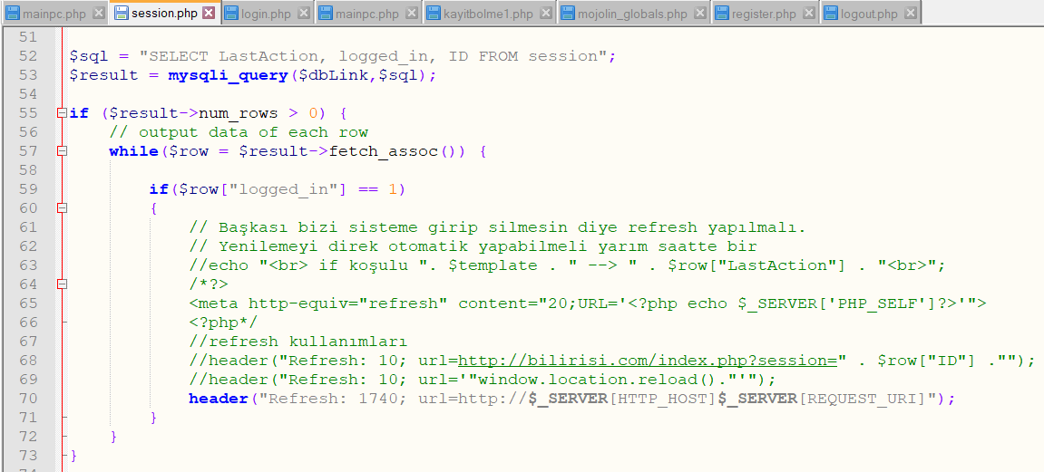 Figure 2.2.1. Refresh the current page after 1740 seconds
In addition, I have ensured the refresh command enter before the delete command from taking the end of session.php. Otherwise, typing refresh command would not change anything.
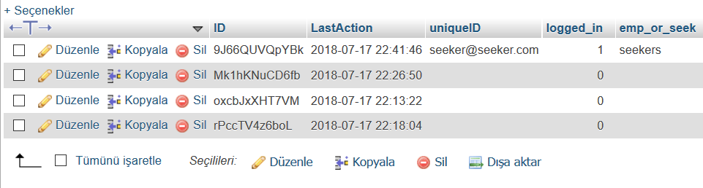 Figure 2.2.2. Some SessionID’s and LastAction times in the session.sql
  - How to use the Cookies?
What is the cookies?
A cookie is a small amount of text data given to a web browser by a web server. The data is then stored on the visitor's hard drive and returned to the specific web server each time the browser requests a page from that server. The main purpose of cookies is to assign a unique identifier to each visitor to a specific website, which allows that website to track that visitor as they navigate through that site. The name cookie is derived from UNIX objects called magic cookies. These are tokens that are attached to a user or program and change depending on the areas entered by the user or program (Josh Manion, 2011).⁸
I watched a lot of videos about cookies. I tried to write the trial code through Localhost. I will share this trial code in the Appendices. I didn’t know how to implement cookies at the http://bilirisi.com/.

- RELATED TO PERSONAL INFORMATION PAGE
  - Save the Personal Information in the Databases
After you have logged-in to the Employee or Company section, the statements we have written in my Personal Information and my Company Information sections were not saved in the databases. It also didn’t show anything as a username before something was written in the name box. Instead, I added Figure 3.1.1 code after log-in in mainpc.php in order to display the e-mail address as user name when the name box is empty.
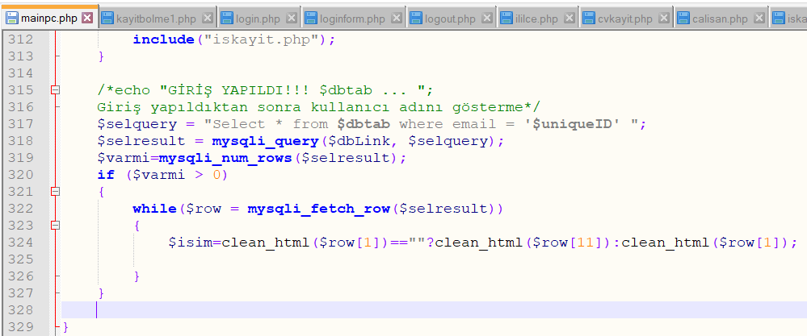 Figure 3.1.1. For show the e-mail address as user name if the name box is empty
In order to register the changes we have made in my Personal Information and my Company Information sections to the jobseeker and hrcontact databases called $dbtab, and cvkisisel, iskisisel databases;

-I added the code snippet in Figure 3.1.2 to cvkayit.php file.
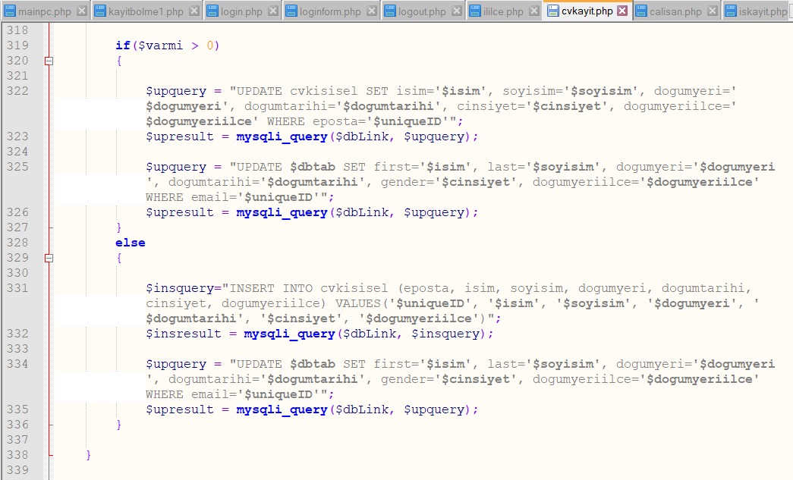 Figure 3.1.2. For save the personal information to the databases
-I added the code snippet in Figure 3.1.3 to iskayit.php file.
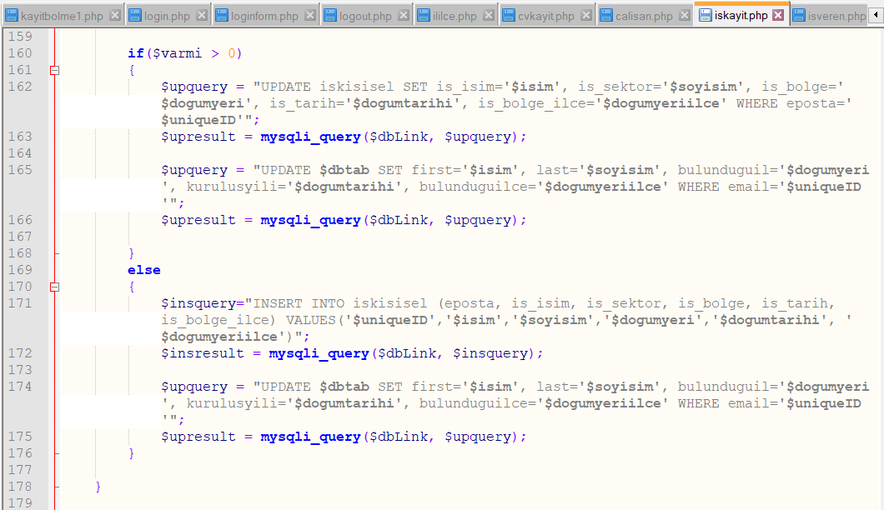 Figure 3.1.3. For save the firm information to the databases
  - Show the Province & District Databases in the Personal Information Page
My Personal Information page included Name, Surname, Birth Place, and Birth Date boxes. Although there were Province and District databases (il.sql, ilce.sql), something random could be written in the Birth Place box. I have added an extra new box to appear the Districts on my Personal Information page. I tried to add a set of code snippets to the bilgilerim.php file in order to ensure that the Province and District databases appear in the Birth Place, Birth Place District boxes.
I tried to add Figure 3.2.1 in order to be able to take the Districts from the database and display them on the screen without registering according to the Province 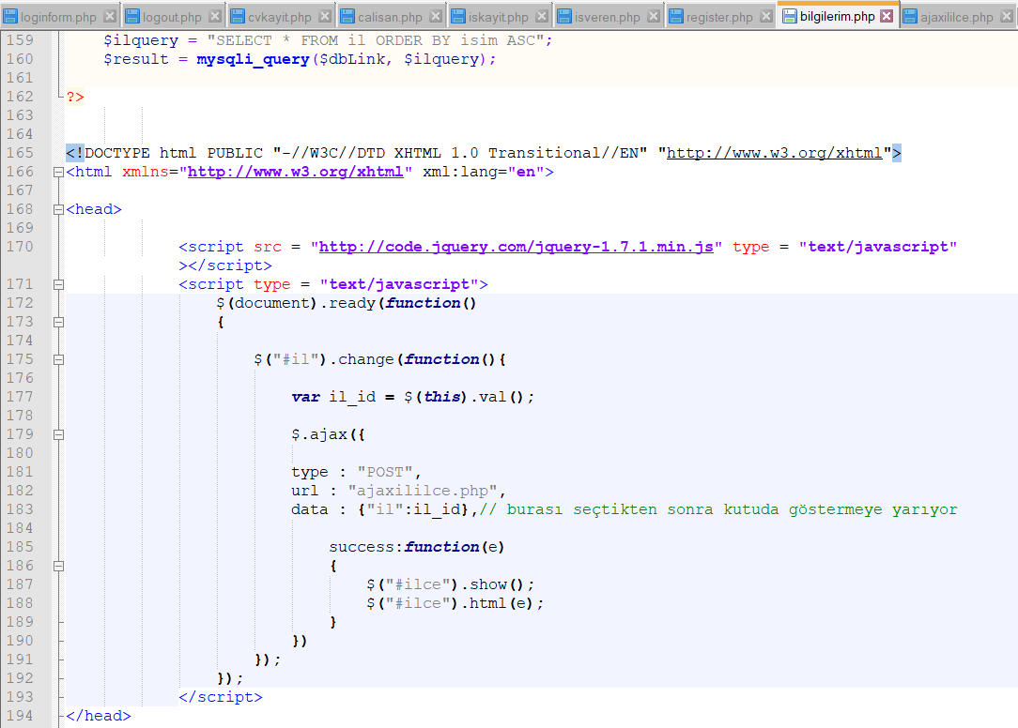 Figure 3.2.1. Javascript Code Snippet in the bilgilerim.php
selected by ajax javascript code section. In this javascript code, I pulled the District database from the ajaxililce.php file with ajax command. (I will share the ajaxililce.php file in the Appendices.)
I also added the if selected command to display the Provinces and Districts that are registered to $dbtab databases.
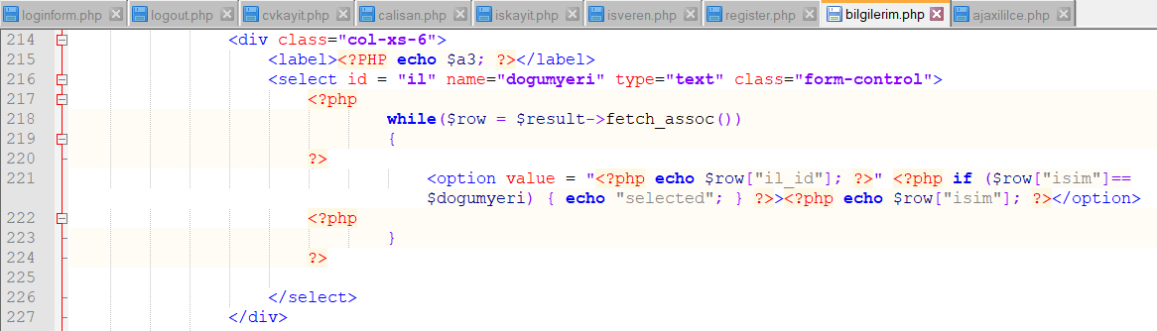 Figure 3.2.2. For show the il.sql database in the Birth Place box
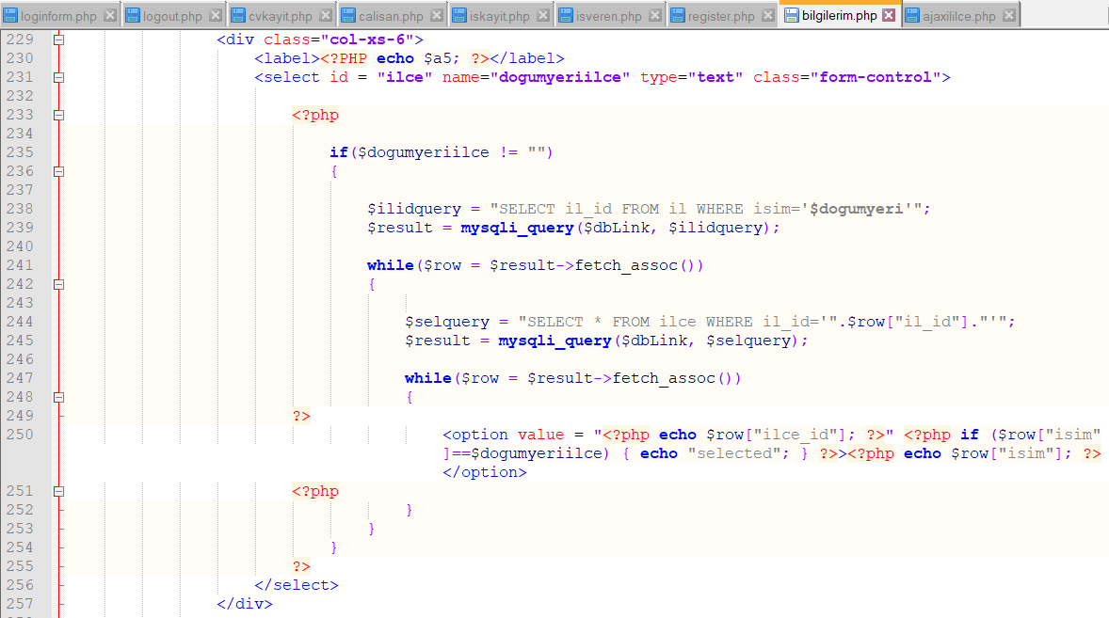 Figure 3.2.3. For show the ilce.sql database in the Birth Place District box

Finally, In the gender section, I added the if checked command in order to display the gender recorded in the $dbtab databases on the screen.
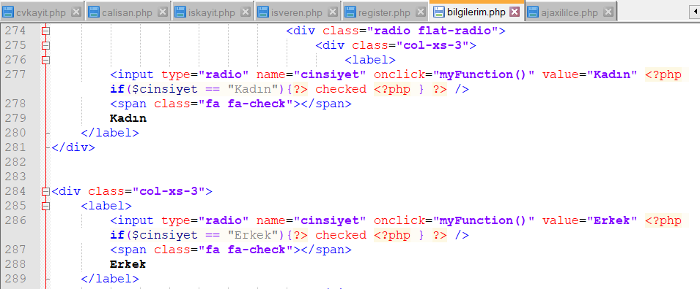 Figure 3.2.4. if checked command for show the recorded gender on the screen

- LOG-IN & SIGN-UP WITH GOOGLE & FACEBOOK
  - Why is the Sign-up through Social Network Important for Any Users?
Social login is one of the ways you can provide a better user experience to your visitors and customers. Since people are perpetually logged-in, especially to their Facebook and Google accounts, sites and apps (ecommerce or otherwise) would do great to provide social log-in. You can reap the following benefits:
1- Save visitors' time by not requiring them to create yet another profile.
2- Increase your chances of converting them to customers.
3- Speed up customer service and support.
4- Automate data collection to build profiles and personas. (Rohan Ayyar, 2015)⁹

  - How to Log-in & Sign-up with Google?
I’ve watched a lot of videos and done a set of research on the internet to be able to log-in with Google and transfer the information on Google to $dbtab databases. I tried to run the codes that in the video. However, the log-in was not succeed even on the account that I received the $google_client_id, $google_client_secret values. I couldn’t adapt them to http://bilirisi.com/. When I tried to do the adaptation, I started to receive various errors. I will share the necessary php files in the Appendices.

  - How to Log-in & Sign-up with Facebook?
I’ve watched a lot of videos and done a set of research on the internet to be able to log-in with Facebook and transfer the information on Facebook to $dbtab databases. I tried to run the codes that in the video. The some codes were run on the Localhost. However, the log-in was succeed only on the account that I received the $appId, $appSecret values. I couldn’t adapt them to http://bilirisi.com/. When I tried to do the adaptation, I started to receive various errors. I will share the necessary php files in the Appendices.

  - Social Media Accounts
I created the necessary social media accounts to be used by http://bilirisi.com/ and shared it by adding links to footer.php.
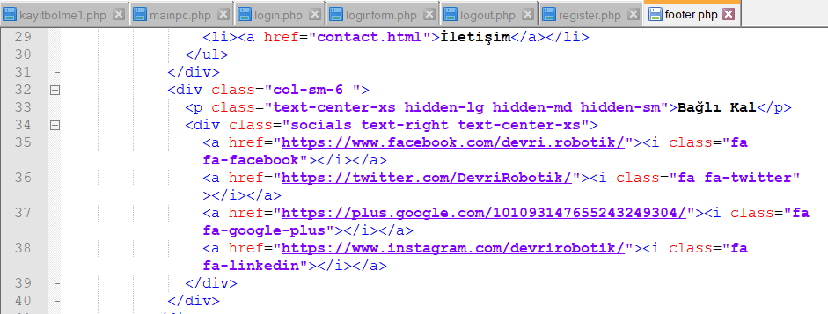 Figure 4.4.1. The social media accounts of Bilirisi
- SHOW THE CV PHOTO
  - Save the Cv Photo in the Database
After uploading a photo in the photo upload section, I tried to add a few code to resimyukle/resimup/upload.php file in order to register to the cvfoto database.
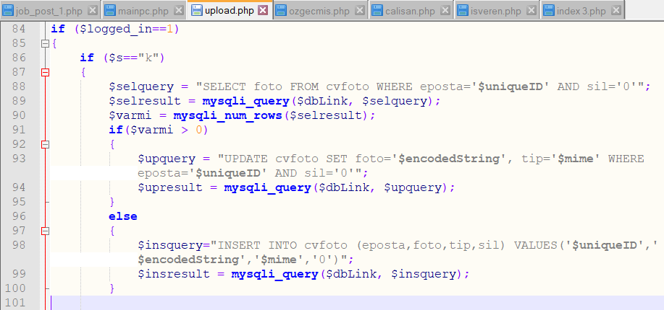 Figure 5.1.1. For save the cv photo in the database

  - Show the Cv Photo in the User Profile
After uploading a photo in the photo upload section, I tried to add a few code to the mainpc.php file in order to display it in the profile at the top of the screen.
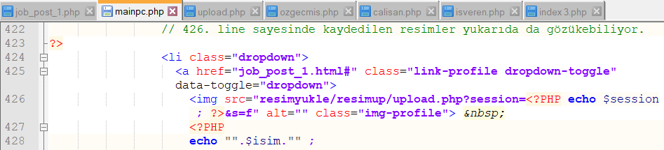 Figure 5.2.1. For show the cv photo in the user profile
  - Show the Saving Picture in the User Profile
I tried to add a few code to the resimyukle/resimup/upload.php file in order to display the image that we saved to the database when no photo was uploaded in the photo upload section.
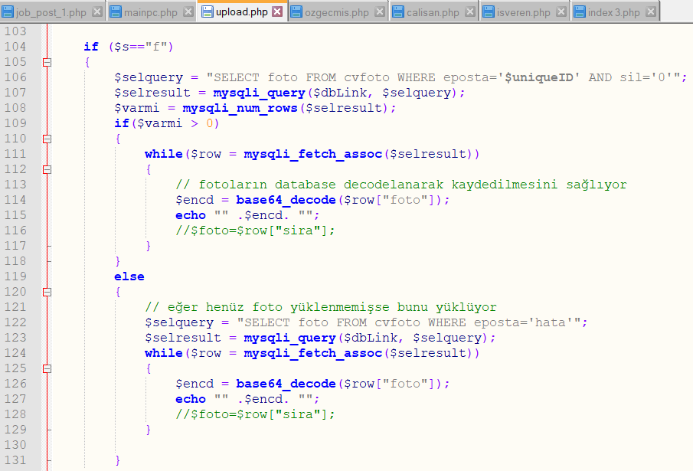 Figure 5.3.1. For show the saving image in the user profile
With eposta=’hata’ that in Figure 5.3.1, I have uploaded the image to the database before. So, this image was called hata. The command that in Figure 5.2.1 runs automatically after the login event in mainpc.php to be able to see this image of the new users.

APPENDICES
Appendix-1. Password Constraints
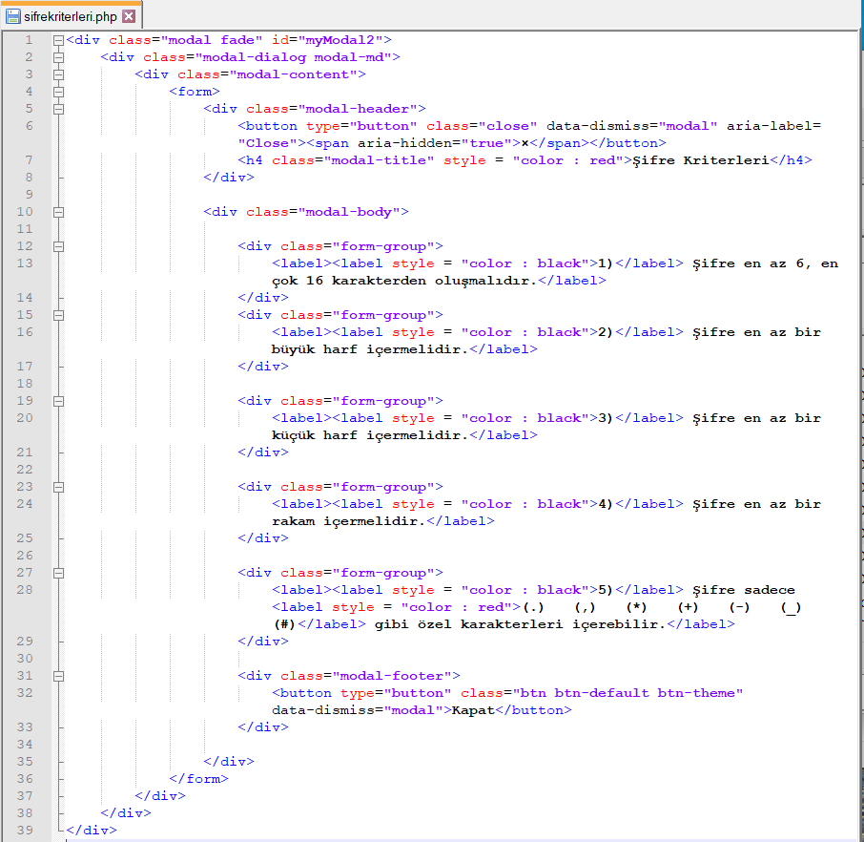 Figure Appendix-1.1. sifrekriterleri.php file

The appearance of the sifrekriterleri.php file on the screen is Figure Appendix-1.2.
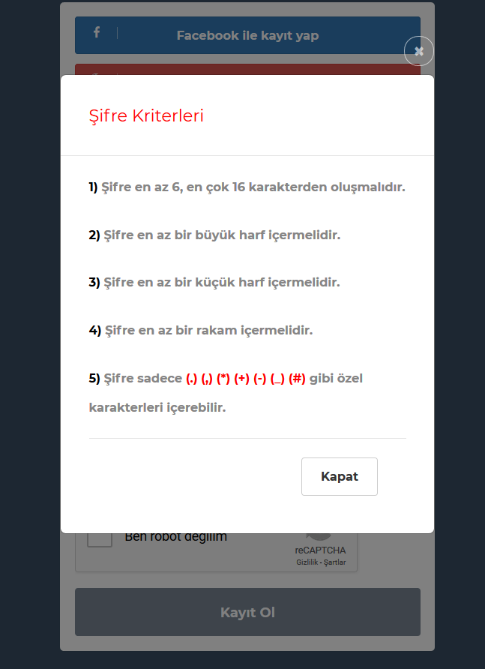
Figure Appendix-1.2. The screenshot of password constraints

Appendix-2. Cookies Codes in the Localhost
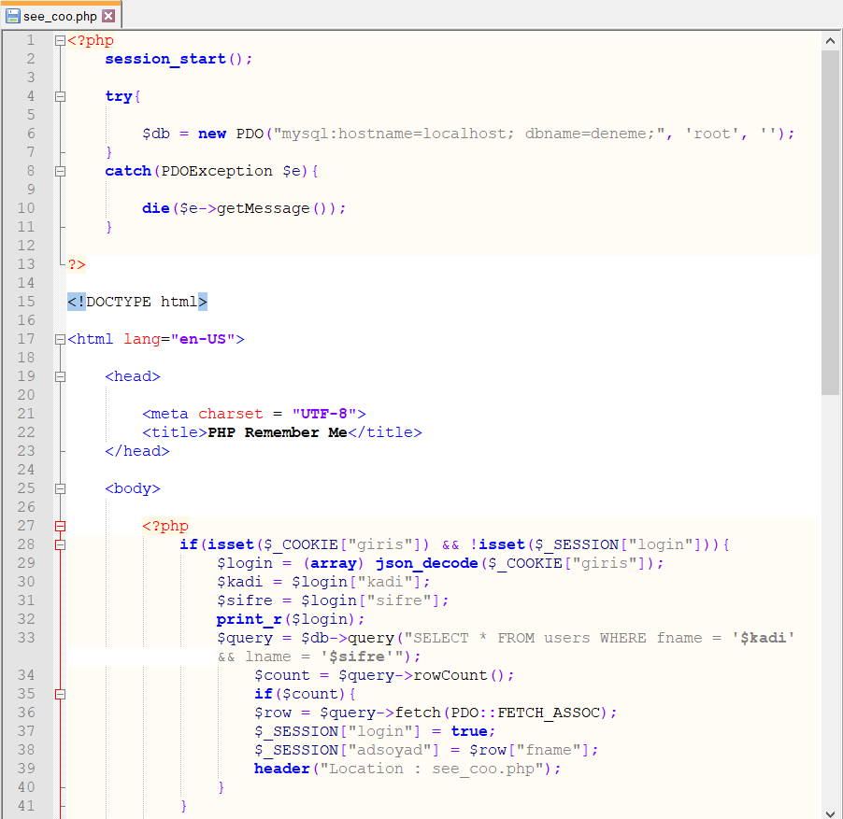 Figure Appendix-2.1. see_coo.php file

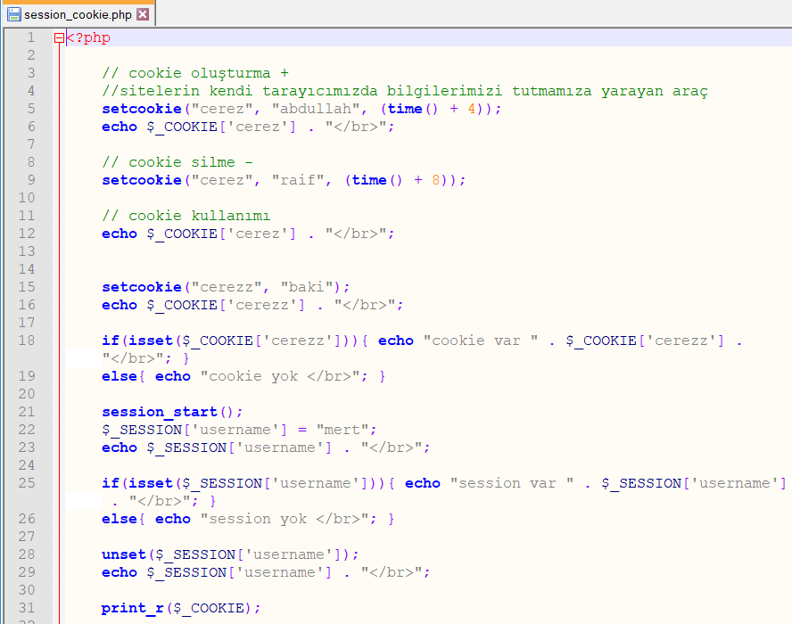 Figure Appendix-2.2. session_cookie.php file¹⁰
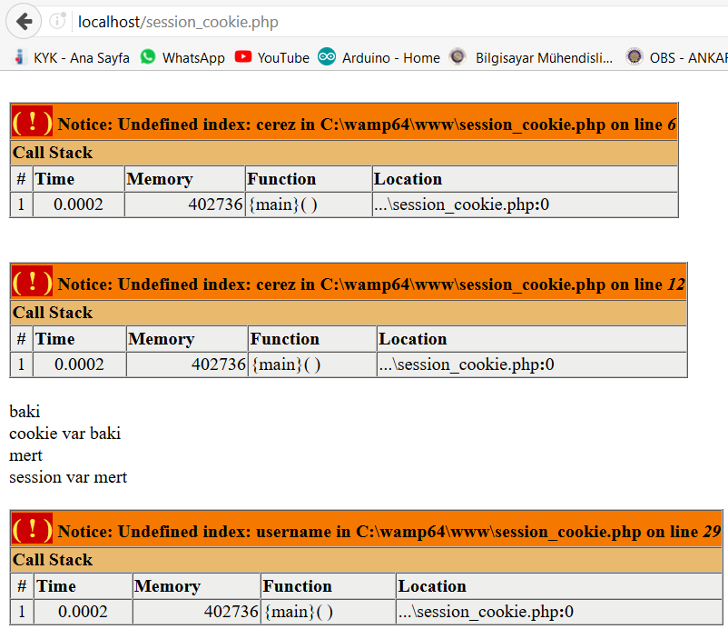 Figure Appendix-2.3. The screen shot of session_cookie.php¹⁰
Appendix-3. ajaxililce.php and Personal Information Page
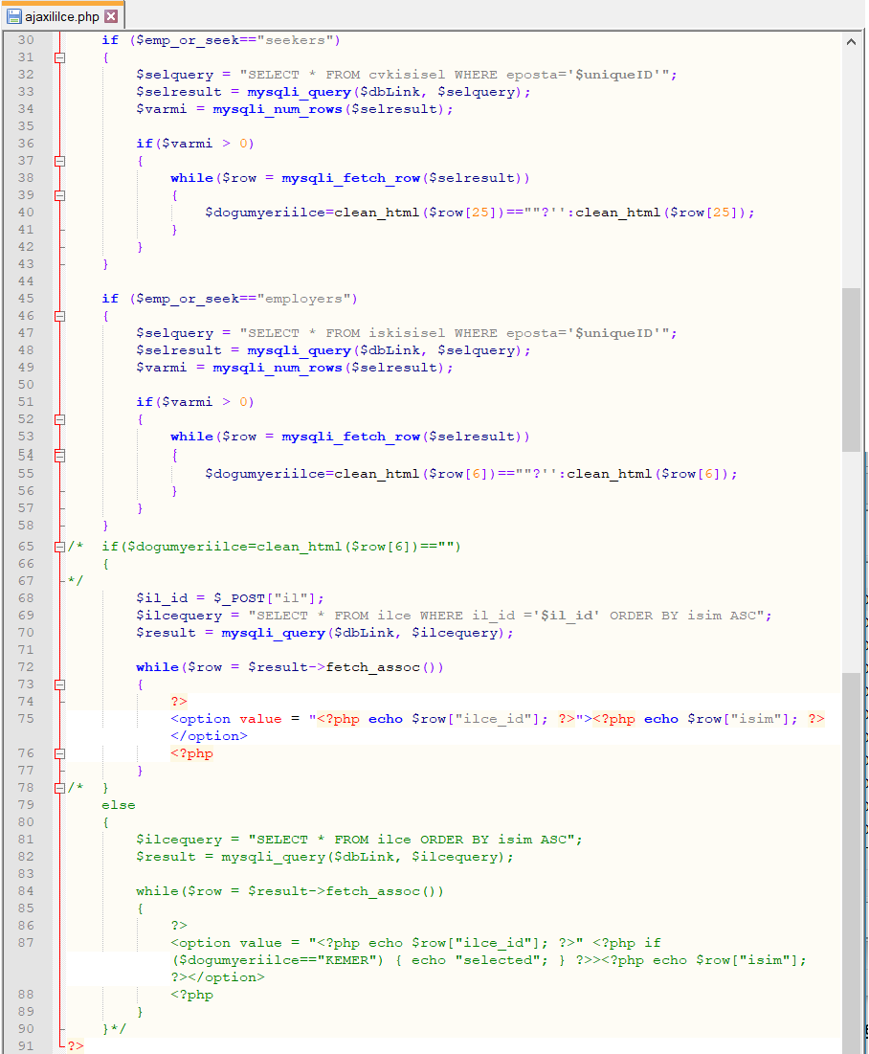 Figure Appendix-3.1. ajaxililce.php file
We pull the District of that Province from the database according to Province selected in the ajaxililce.php file.
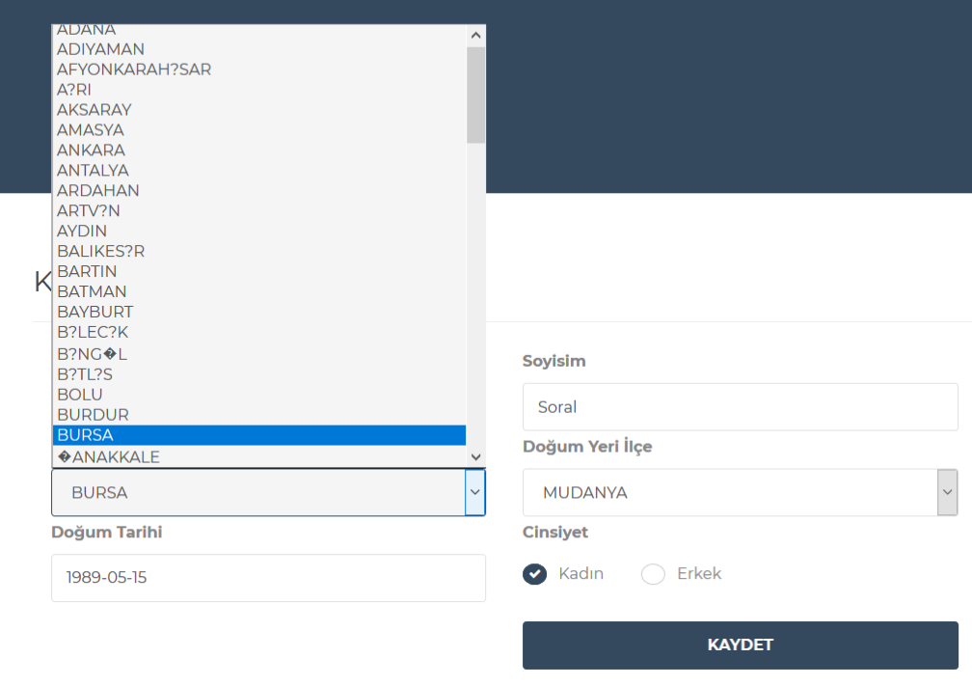 Figure Appendix-3.2. The screenshot of the personal information

Appendix-4. Log-in & Sign-up with Google Codes in the Localhost

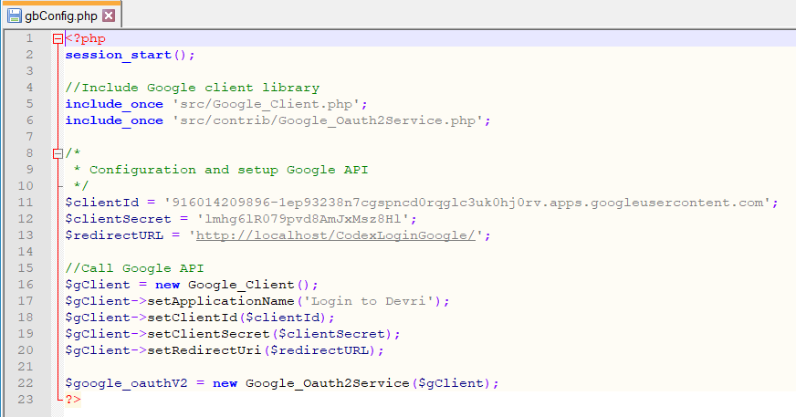 Figure Appendix-4.1. gbConfig.php file in the CodexLoginGoogle folder¹¹
The codes in the CodexLoginGoogle folder do not react in any way.

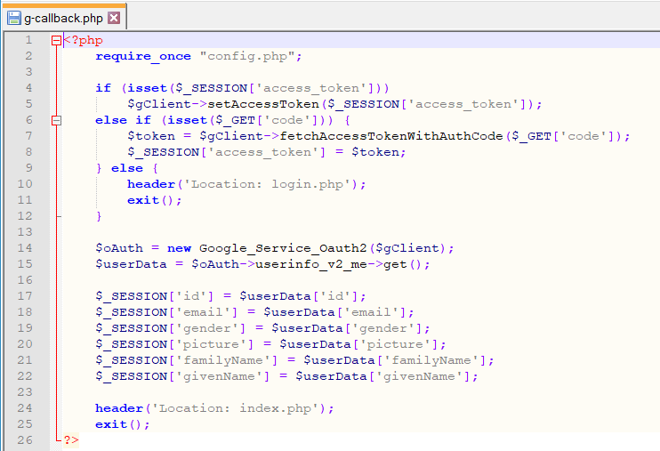 Figure Appendix-4.2. g-callback.php file in the GoogleLoginAdam folder¹²

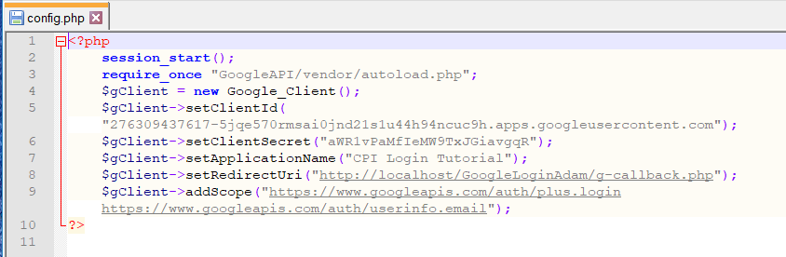 Figure Appendix-4.3. config.php file in the GoogleLoginAdam folder¹²
When you apply things that in the GoogleLoginAdam folder, you can log-in successfully. But, it shows the error message in the next page.

Appendix-5. Log-in & Sign-up with Facebook Codes in the Localhost
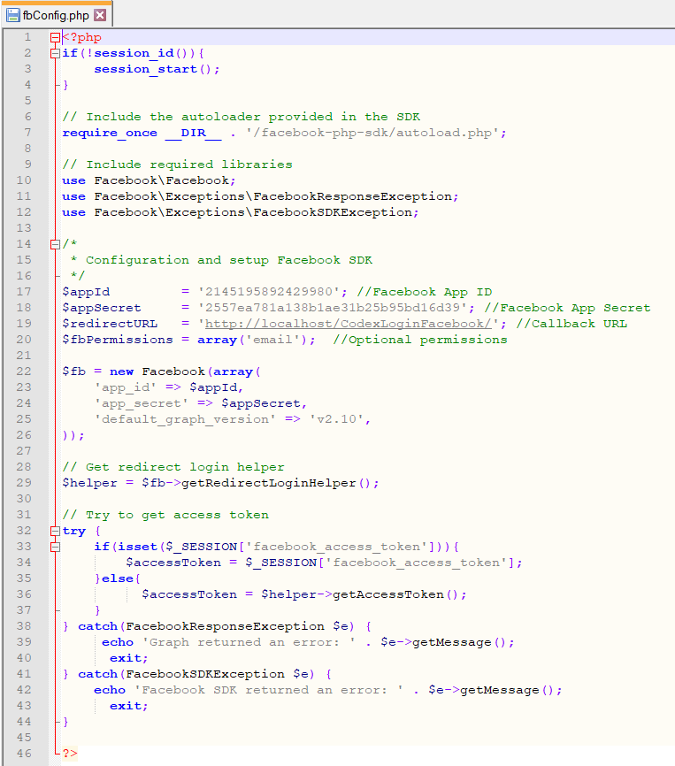 Figure Appendix-5.1. fbconfig.php file in the CodexLoginFacebook folder¹³
The log-in was succeed on the account that I received the $appId, $appSecret values (Figure Appendix-5.2). Then it is saved the new user to the db_users.sql database on the localhost/phpmyadmin/ server (Figure Appendix-5.3).

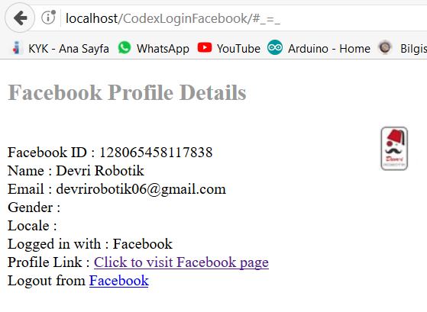 Figure Appendix-5.2. After from the log-in or sign-up

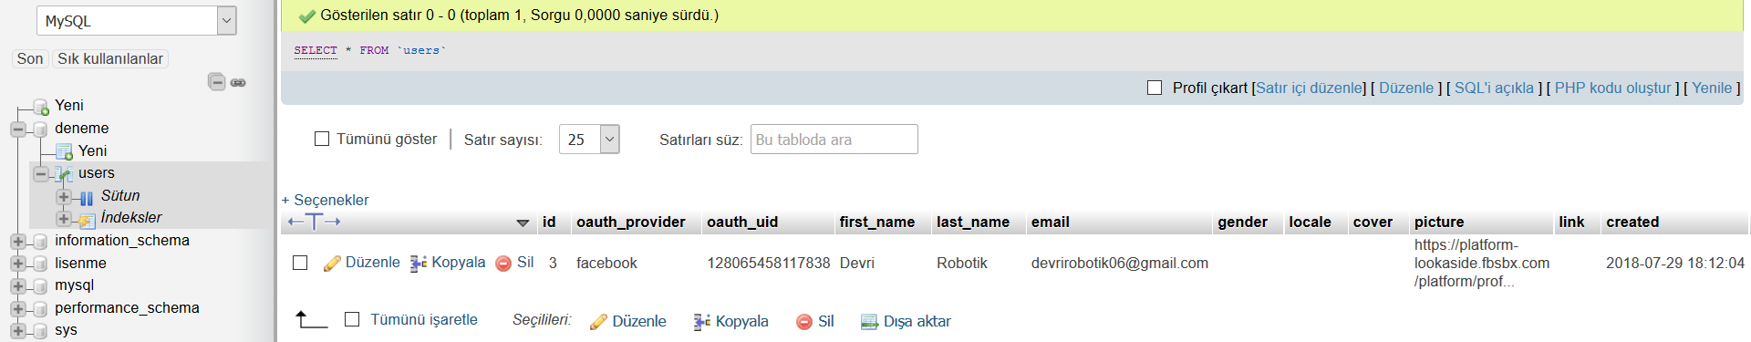 Figure Appendix-5.3. Save the database after the first sign-up

However, when I adapt this code to the site, I get error messages when logging-on the http://bilirisi.com/CodexLoginFacebook/ page (Figure Appendix-5.4). I tried to search these error messages from the internet. Everywhere was said something 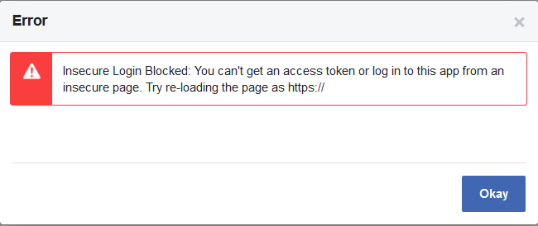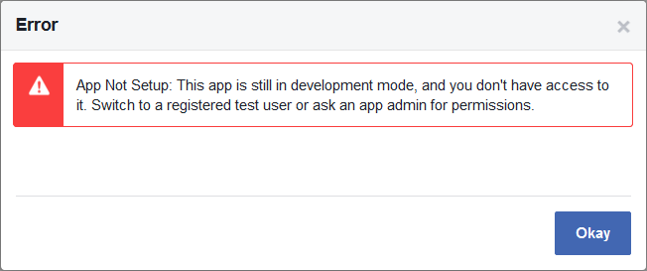
Figure Appendix-5.4. The errors of facebook log-in
different. Firstly, I should allow public entries in the Facebook SDK. Then there was a file called “ngrok.exe”. If I download it from cmd and type the “ngrok http 80”, it is given a link that is https:// extension. But, it still continued giving the same error on that link.¹⁴

Appendix-6. Cv Photos
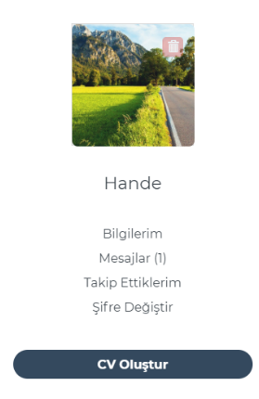
Figure Appendix-6.1. Cv photo upload this frame Figure Appendix-6.2. The image that is called “hata”
1 Figure Appendix-6.3. The user profile while there is not a photo
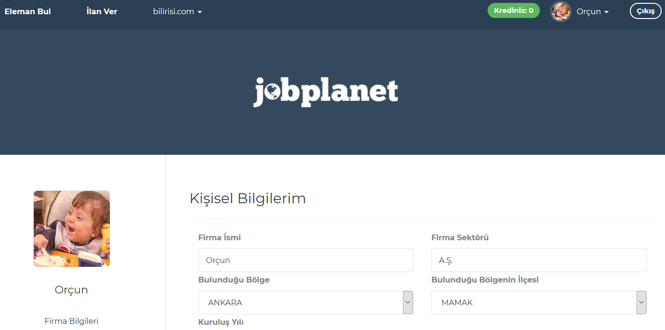 Figure Appendix-6.4. The user profile while there is a photo
CONCLUSION
I tried to fix the site’s deficiencies and mistakes. I’ve learned a lot of things while doing all of this; -How to insert, how to update, how to delete a data from the database? -What can be done with Php, Html codes? -How can a website be set up? My internship gave me an idea of all this.
In addition, my internship has given me a lot of information about how our business life will be and how it should be. As an engineer; -If there is a problem, we should be able to do this as soon as possible. -We have to understand a problem in the best way and we have to implement in the best way what we understand. -We should never say we cannot solve this problem.
As a result, internship training has been a process in which we have developed our knowledge and skills, that we have seen how the theoretical knowledge or practices that we have acquired at school can be came to realize in the business environment.

BIBLIOGRAPHY

(1) Şifreleme Yöntemleri, Spt 07, 2013, Seyir Defteri, ITUBIDB, https://bidb.itu.edu.tr/seyir-defteri/blog/2013/09/07/%C5%9Fifreleme-y%C3%B6ntemleri
(2) 74,76 pages, Chapter 4.ppt, 2010, Introduction to Computer Science lesson, Ankara University
(3) MD5 (Message Digest, Mesaj Özet), Apr 30, 2008, Bilgisayar Kavramlari, Şeker Şadi Evren, http://bilgisayarkavramlari.sadievrenseker.com/2008/04/30/md5-message-digest-mesaj-ozet/
Kriptoloji 12 Hash (Özetleme) Fonksiyonları ve MD5, Jan 10, 2016, Bilgisayar Kavramlari, Şeker Şadi Evren, https://www.youtube.com/watch?v=2AmKrvTdH-g
How to implement sha 512, md5 and salt encryption all for one password [duplicate], Feb 11, 2014, stackoverflow, https://stackoverflow.com/questions/21711890/how-to-implement-sha-512-md5-and-salt-encryption-all-for-one-password
(4) Password Policy, Wikipedia, https://en.wikipedia.org/wiki/Password_policy
(5) Password Constraint, Oxford Reference, http://www.oxfordreference.com/view/10.1093/oi/authority.20110803100309524
Create preg_match for password validation allowing (!@#$%), Aug 8, 2012, stackoverflow, https://stackoverflow.com/questions/11873990/create-preg-match-for-password-validation-allowing
User Id & password constraints checker, Aug 24, 2017, Stack Exchange, https://codereview.stackexchange.com/questions/173831/user-id-password-constraints-checker
(6) reCAPTCHA, Wikipedia, https://en.wikipedia.org/wiki/ReCAPTCHA
PHP Tutorial For Beginners: Google reCAPTCHA v2, May 29, 2017, Coding Passive Income, https://www.youtube.com/watch?v=xyOu0b6R3m0
Way to skip reCAPTCHA images challenge, Aug 24, 2017, stackoverflow, https://stackoverflow.com/questions/45754869/way-to-skip-recaptcha-images-challenge
Session (computer science), Wikipedia, https://en.wikipedia.org/wiki/Session_(computer_science)
(7) Session Nedir?, wmaraci, https://wmaraci.com/nedir/session
What is a PHP Session?, w3schools, https://www.w3schools.com/php/php_sessions.asp
Login form using session and cookie with remember me in php, May 15, 2016, learnWebCoding, https://www.youtube.com/watch?v=3jfBOD5Mw0Q
session_create_id, php manual, http://php.net/manual/en/function.session-create-id.php
Get the full URL in PHP, Feb 02, 2014, stackoverflow, https://stackoverflow.com/questions/6768793/get-the-full-url-in-php
How to redirect to the same page in PHP, Oct 28, 2016, stackoverflow, https://stackoverflow.com/questions/8130990/how-to-redirect-to-the-same-page-in-php
Php refresh current page?, Nov 19, 2010, stackoverflow, https://stackoverflow.com/questions/4221116/php-refresh-current-page/4221146
Php header() kullanımı, Feb 02, 2013, Mahmut Aydın’ın Web Notları, http://www.aydinmahmut.com/php-header-kullanimi/
(10) Sıfırdan Php dersleri - Cookie - Session - Kullanımı, Nov 13, 2015, Mert Buldur, https://www.youtube.com/watch?v=ySz2CaAQacA
Php’de Cookie Kullanımı (Ders 39), Dec 14, 2012, Prototürk - Yazılım ve Tasarım Dersleri, https://www.youtube.com/watch?v=gIU3NO4GTho
Session id’s, database, cookies and Access levels, Oct 11, 2011, Michael Lowe, https://www.youtube.com/watch?v=rdmxkVzyH6s
What is a Cookie?, w3schools, https://www.w3schools.com/php/php_cookies.asp
(8) Understanding Cookies, Apr 15, 2011, Manion Josh, http://web.archive.org/web/20110415181139/http:/www.stratigent.com/web-sight-newsletter/web-analytics-newsletter-archive/understanding-cookies/default.html
Country state city ajax, mysqli, php dropdown example, Oct 21, 2016, Amit Andipara, https://www.youtube.com/watch?v=_zZ-3JERK8g
Php ve ajax ile il ilçe listeleme, Mar 08, 2017, Mert Buldur, https://www.youtube.com/watch?v=F7IOh9ZnGi8
Country-State-City Example: Cascading jQuery Dependent Dropdown, Apr 24, 2018, php pot, https://phppot.com/php/country-state-city-example-cascading-jquery-dependent-dropdown/
How to display the state and city name from the database on edit page?, Spt 15, 2018, stackoverflow, https://stackoverflow.com/questions/52341479/how-to-display-the-state-and-city-name-from-the-database-on-edit-page
I want to display the selected radio buton on my update page, Mar 23, 2017, stackoverflow, https://stackoverflow.com/questions/42944316/i-want-to-display-the-selected-radio-button-on-my-update-page
WordPress Hidden Gems: checked(), selected(), and disable(), Spt 22, 2010, Stephanie Leary, http://stephanieleary.com/2010/09/wordpress-hidden-gems-checked-selected-and-disabled/
PHP - Keep The Values in The Form, w3schools, https://www.w3schools.com/php/php_form_complete.asp
(9) Why is social login important?, Jan 03, 2015, Ayyar Rohan, Quora, https://www.quora.com/Why-is-social-login-important
(12) Login With Google Account Using Php & Client API & Bootstrap Design, Aug 30, 2017, Coding Passive Income, https://www.youtube.com/watch?v=hazMyK_cnzk
(11) Login with Google Account using PHP, Dec 11, 2016, CodexWorld, https://www.youtube.com/watch?v=s6pwjKGdEU8
Facebook Login With PHP SDK v5 & Graph API Tutorial, Aug 28, 2017, Coding Passive Income, https://www.youtube.com/watch?v=1DgzTWr3F2I
(13) Login with Facebook using PHP SDK v5, Mar 29, 2017, CodexWorld, https://www.youtube.com/watch?v=dc7WaCCBgIU

(14) Insecure Login Blocked: You can't get an access token or log in to this app from an insecure page. Try re-loading the page as https://, Apr 17, 2018, stackoverflow, https://stackoverflow.com/questions/49403748/insecure-login-blocked-you-cant-get-an-access-token-or-log-in-to-this-app-from

(14) Expose a local web server to the internet, ngrok, https://ngrok.com/docs

I am getting the error message “Insecure Login Blocked: You can’t get an access token or log in to this app from an insecure page. Try re-loading the page as https://”, Mar 28, 2018, github, https://github.com/r-lib/httr/issues/515

